CPRE Northants - Admin Guide

How to access the WordPress Admin Panel
Visit https://www.cprenorthants.org.uk/wp-admin/ and login with the following login details:
Username: cpre
Password: oi3FmlHTpF2b!M&y5n2VT$9a

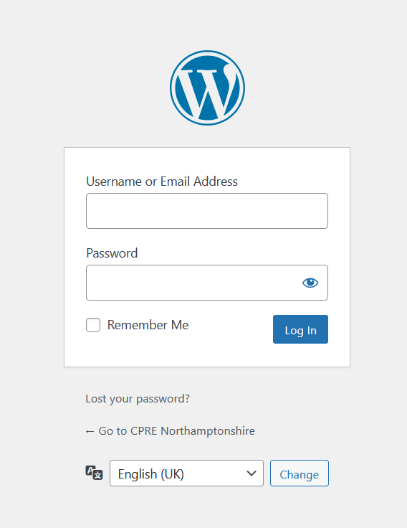

Once you are logged in you will be able to edit the following content.

How to update the Newsletter
To update the newsletter on the home page, click on the ‘Newsletter’ option in the admin:

In this area of the admin you can update the Newsletter PDF and update the button text that appears on the home page button.
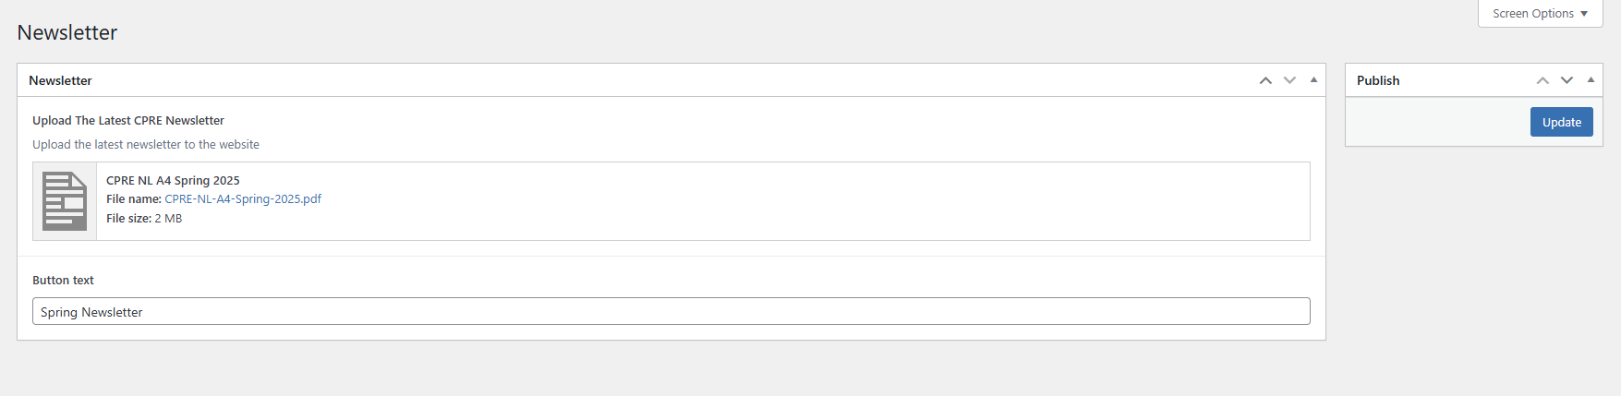
To save the changes click on the Update button under publish in the right sidebar.

How to update the Contact Details
Click on the ‘Contact Details’ option in the left sidebar in the WordPress admin to edit the contact address, email and the phone number.
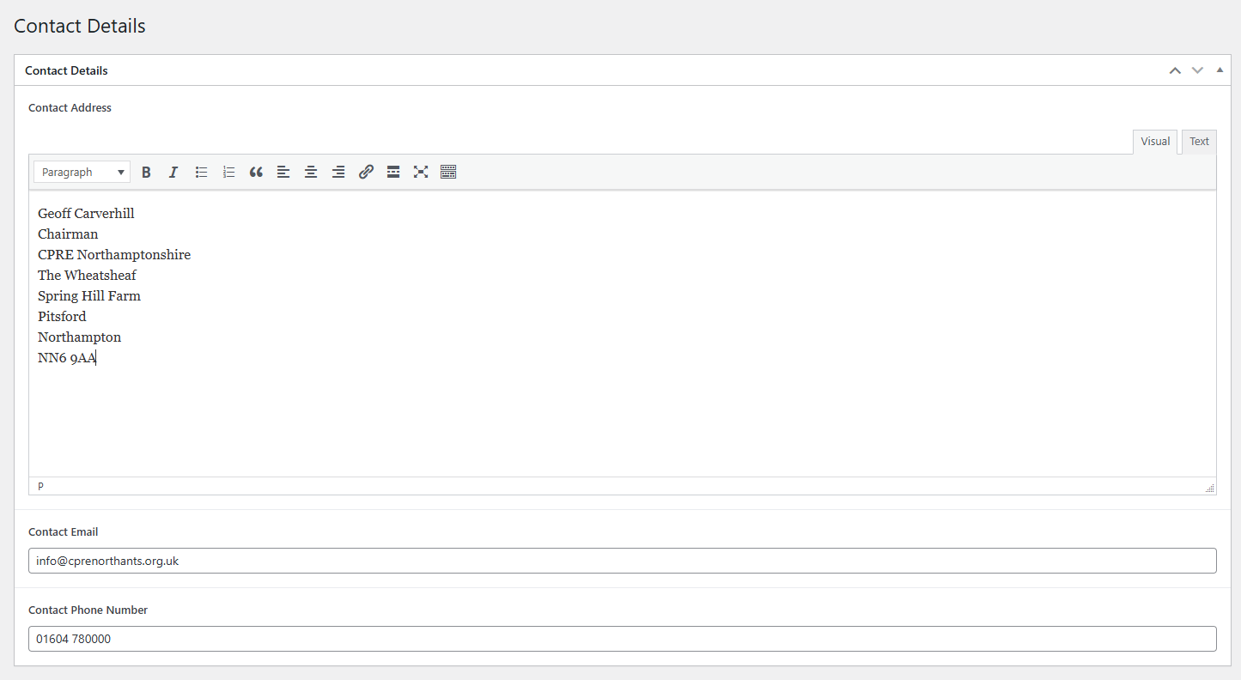
To save the changes click on the Update button in the right side bar:
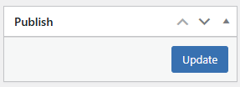

How to add / edit items under Reports & Useful Downloads on the Resources page

Add a new Resource
Click on the Resources option in the left sidebar

To add a new resource, click on the ‘Add New Resource’ button at the top of the Resources page.
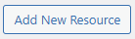
You will then see a new page where you can add the resource title, add a PDF and a description. The resource will be added to the website once it is published by clicking on the Publish button in the right sidebar.
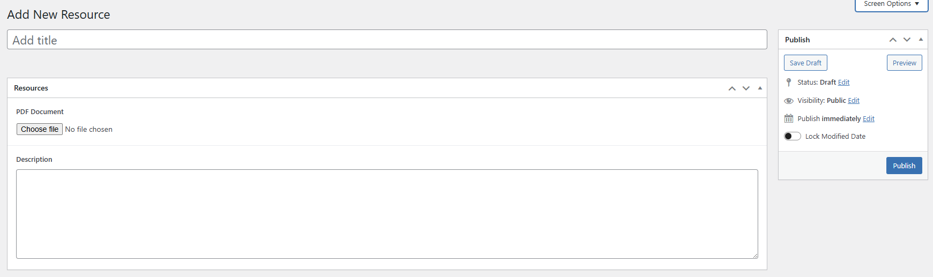
You can save as draft to add a new resource without making it available on the website.

Editing a Resource

Click on the Resources option in the left sidebar

You will then see the resources page that lists all the currently available resources.
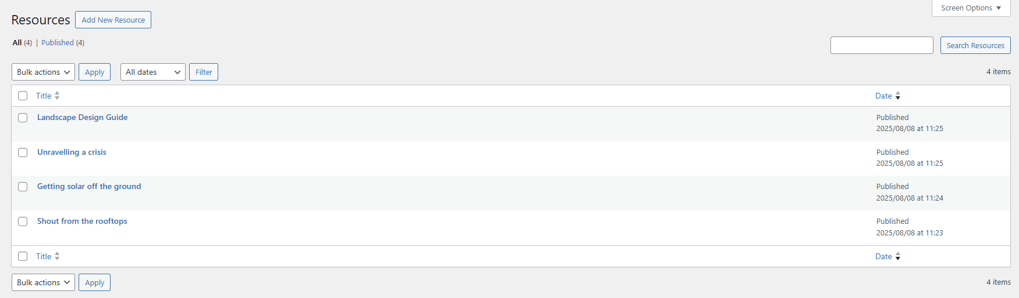
To edit an existing resource, click on the resource and you will be taken to the edit page where you can update the PDF for the resource, the title and the description.
To save the changes you will need to click on the Update button in the right sidebar.

How to add more planning responses to the website

Add a planning response
Click on the Planning option in the left sidebar of the admin.
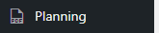
You will then see the planning page that lists all the currently added planning responses.
Click on the ‘Add New Planning’ button to add a new planning response.
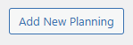
You will then see a new page where you need to add the title, upload a PDF, add a description and select a category/categories which is used for the filter.
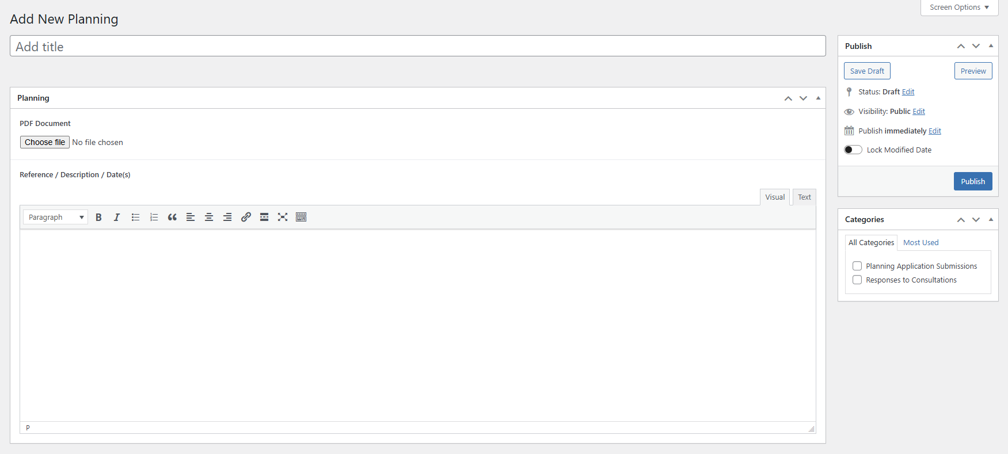
The planning response will be added to the website after it has been published. This is done by clicking on the publish button in the right sidebar.
You can save as draft to add a new planning response without making it available on the website.

Edit an existing planning response
Click on the Planning option in the left sidebar of the admin.
You will then see the planning page that lists all the currently added planning responses.
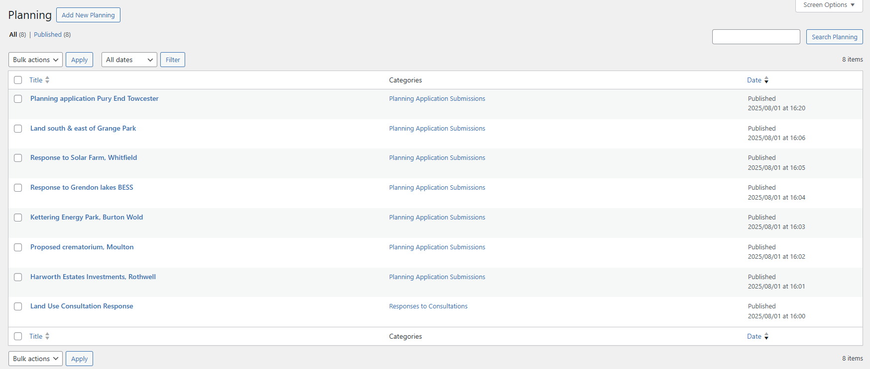
To edit an existing planning response you need to click on the title which will then take you to the edit page.

Edit Page
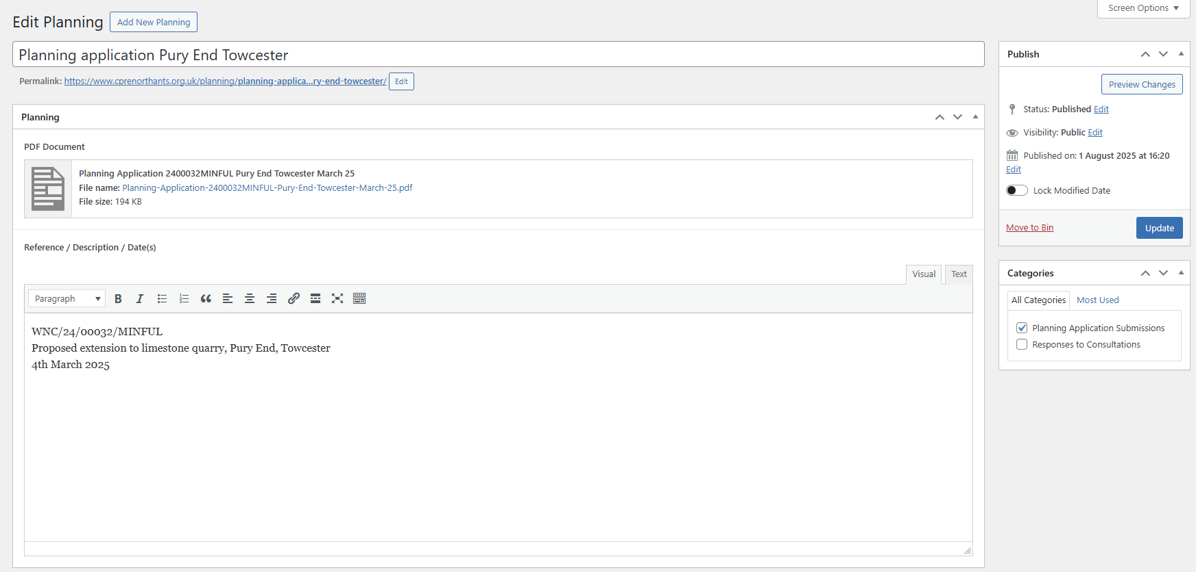
You will be able to edit the title, PDF document, Description and the categories (in the right sidebar).
To save the changes click on the Update button in the right sidebar.

Change password
Click on the ‘Profile’ option in the left sidebar.

Scroll down the profile page until you see the option to ‘Set New Password’ and click on the button.
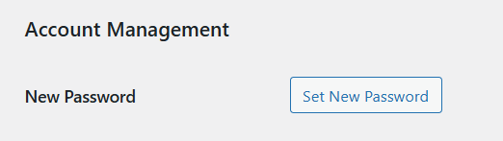
Set your new password and then click on the Update Profile button at the bottom of the page.
